Indications For Specialist Referral : Unexplained vaginal bleeding, Personal/family (1st deg relative) history of VTE, Personal history of breast, endometrial or endometroid ovarian cancer, Otosclerosis, Undiagnosed breast lump, Active liver disease, Migraine with aura
Cautions: Fibroids, Hypertension, Migraines, Endometriosis, Family history of breast cancer (can give HRT, but monitor closely)
What To Do In a Review: @3m: discuss symptom control, bleeding pattern, side effects; check BP & adjust dose if needed; @6m: same as 3m; @ 12m: as 3m plus weight; mammography to be repeated according to NHS breast screening programme.
Treatment Duration: Symptom Relief: 3-5y then gradual withdrawal, continue Rx if symptoms recur; Osteoporosis: 5-10y; Premature Menopause: treat to age 51, then review and discuss benefits vs risks with patient (increased risk of breast Ca applies only after average age of menopause (ie 51)
Contraception
HRT is not a contraceptive
<50y: continue contraception for 2y after menopause
>50y: continue contraception for 1y after menopause
If HRT is started premenopausally, the last period is masked, and fertility status is therefore unclear. Contraception is advised until age 54, when 80% women will be post menopausal
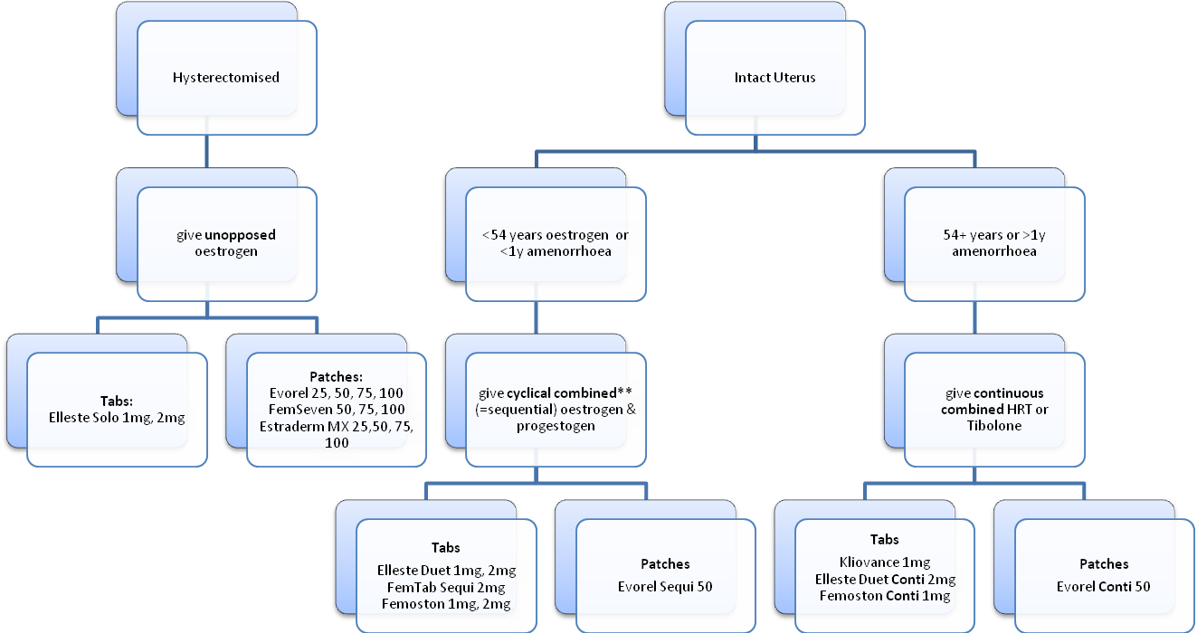
** change to continuous combined regime if therapy required for more than 2 years

